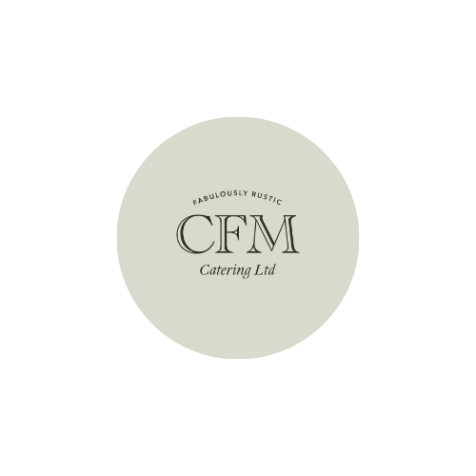
CFM Catering Ltd
Corporate Catering Menu
Please email all orders: cfmorder604@gmail.com

Breakfast Options
Freshly Baked Scones €2.50
Butter Croissants €1.50
Overnight oats €4.50
Danish pastries €2.50
Traybakes €3.00

Salads
Goat’s Cheese Salad €9.95
Mixed salad leaves tossed in a mustard dressing topped with toasted hazelnuts, rocket leaves, red onion marmalade, and crumbed goat’s cheese. Served with homemade brown bread.

Korean BBQ Chicken Salad €9.95
Marinaded Chicken, Mixed Leaves, cucumber, raspberries, sesame seeds & red cabbage coleslaw

Chicken Caesar Salad €7.50
Vegetarian Salad €6.50

Gourmet Sandwiches (Wraps/ciabattas/Bagels/Sourdough)
We can deliver these as Toasties €6.95
All served with Salsa on the side and crinkle-cut crisps. Packaged in individual boxes.

- Cajun Chicken, Sage and Onion Stuffing, Smoked Cheese with Garlic Mayo
- Mature Chedder, Rocket, Red Onion, Sundried Tomato & Pesto
- Pulled Ham with Fig Jam and Mozzarella
- Toasted Special with Dijon Mustard Mayo

Finger Food Menu
Cocktail Sausages (Also available with Honey & Mustard) | €1.00pp (6pp)
Prawn & Chorizo Skewers | €1.50 each
Potato Wedges | €2.00pp
Chicken Goujons with a selection of dips | €2.50pp(3pp)
Southern Fried Goujons | €2.50pp (3pp)
Sandwich Selection (1.5 sandwiches per person catered for) | €4.75 pp
Platters of Fruit | €2.75pp

